Finding Files and Folders with Database Queries
A technical reference by Marie Kelly, ©2026
Introduction
Technical Requirements
Summary of Process Steps
Details of Process Steps
Database Queries

Further reference:
The dir command
Essentials of the Database Environment
Finding Files and Folders with Database Queries

Modern personal computers often have the convenience of large capacity memory and data storage, with powerful microprocessors, and sometimes even cloud-based storage backup to protect files. Protecting important files on desktop computers is nearly guaranteed with standard technology. Sometimes things still fall through the cracks, so what can be done when a file goes missing?

In Microsoft Windows-based machines, Windows Explorer has a utility to search files, but the search capability has some limitations. Basically, Windows can search the hard drive for a file name containing certain words or partial name strings.
Complex search criteria, searching multiple file names, searching for identical files in different folders, pattern matching of file names (approximate file name), searching for large files or folders, date ranges of files, and summarizing the contents of folders are tasks not directly available in Windows, but easily accomplished with a few steps using the operating system command "dir" and database software.

Technical Requirements

A Windows-based machine is required, where the user has enough permissions to execute the "dir" command,
and save that output to a text file. A database server and client are required. A database server is needed to import the output file from the directory scan, and a database client is required to run queries against the imported file.
This document demonstrates the process using Microsoft SQL Server database software.
The Microsoft SQL Server database server includes tools to import data, like text files.
SQL Server Management Studio is a database client tool that can query the database server.

Summary of Process Steps

1 Execute the directory scan command, and save that output to a text file.
2 Import the text file into a table in the database server.
3 Use database queries to sort records from the directory output
into file records, directory records and summary records.
4 Run queries against the database tables to identify locations, sizes and dates of files and folders.

Details of Process Steps
Dir.cmd file and output: see additional references at the end of this document, "The dir command".
Create a command file (dir.cmd) at the root of the C:\ drive.
Running the command at the root C:\ drive will capture all files, folders and subfolders on the entire drive.
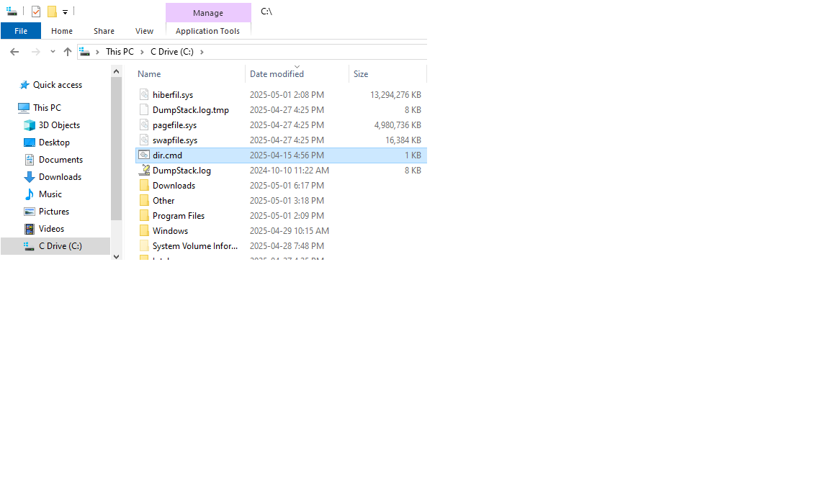
Notice that the text of this command directs the output file to a different directory, C:\Temp\output.txt
It could take a minute or two to execute this command if there are many files on the drive.
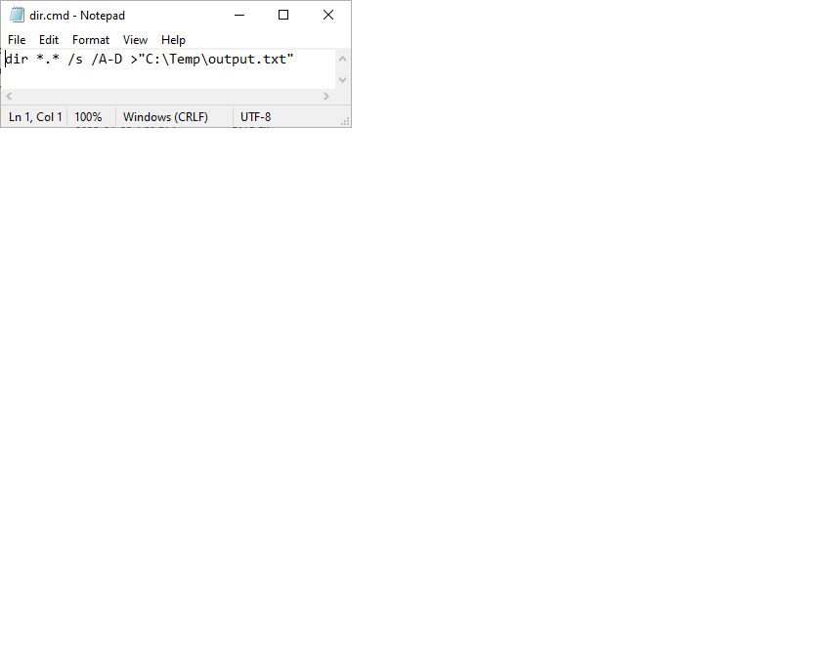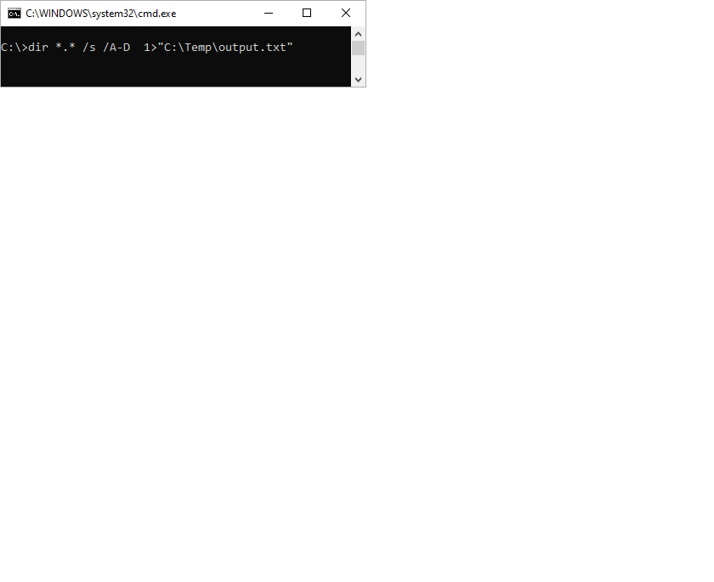
The output of the directory command should look similar to this.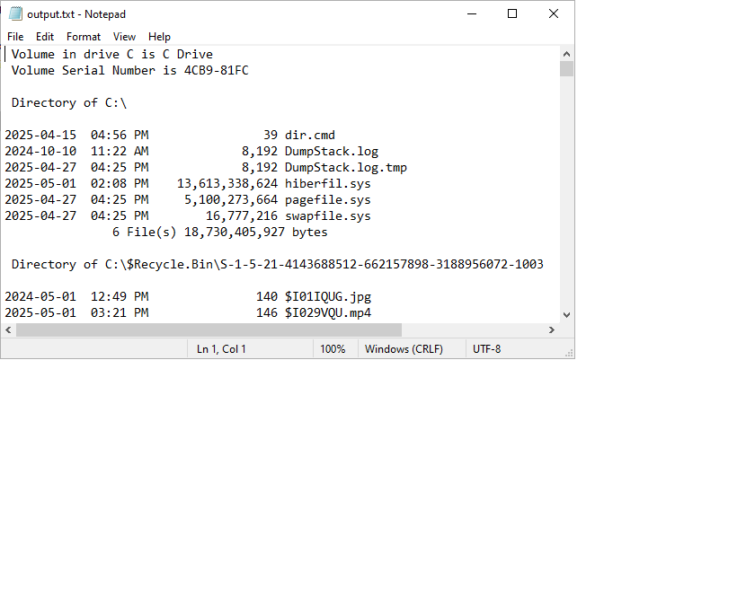
Import the text file into a table in the database server

There are several ways to perform the same task, even in Microsoft SQL Server. The process outlined here is the simplest method to import a text file to a database table, changing the fewest default options as possible. The user needs permissions to create a table and import data into the tempdb database in SQL Server.
Tasks Import Data: right-click on the tempdb database to view the "Import Data" option.
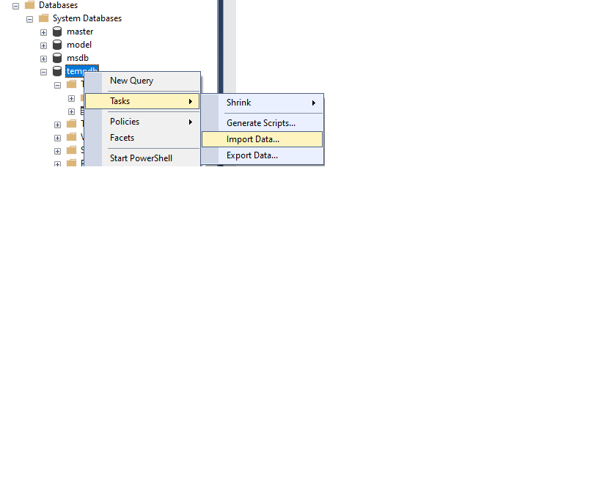

Import and Export Wizard
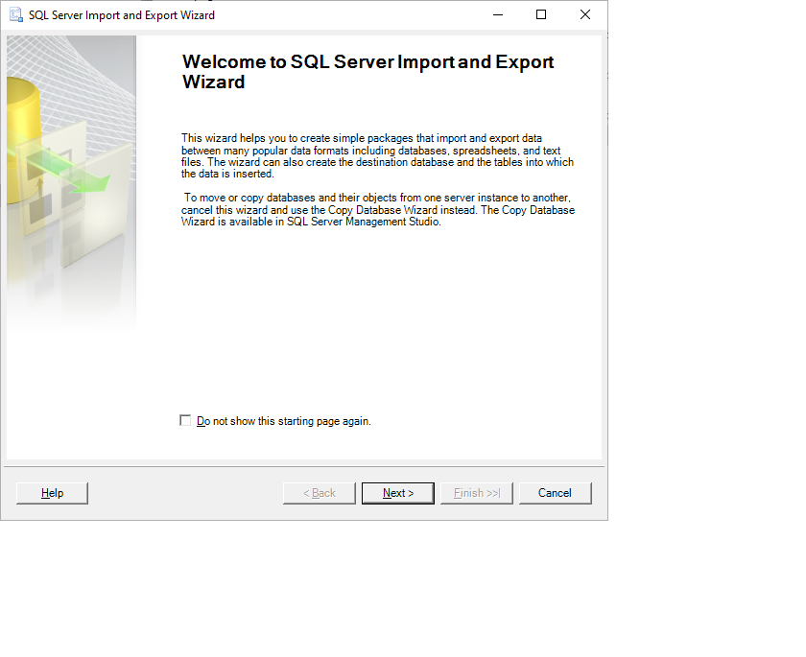

Choose a Data Source
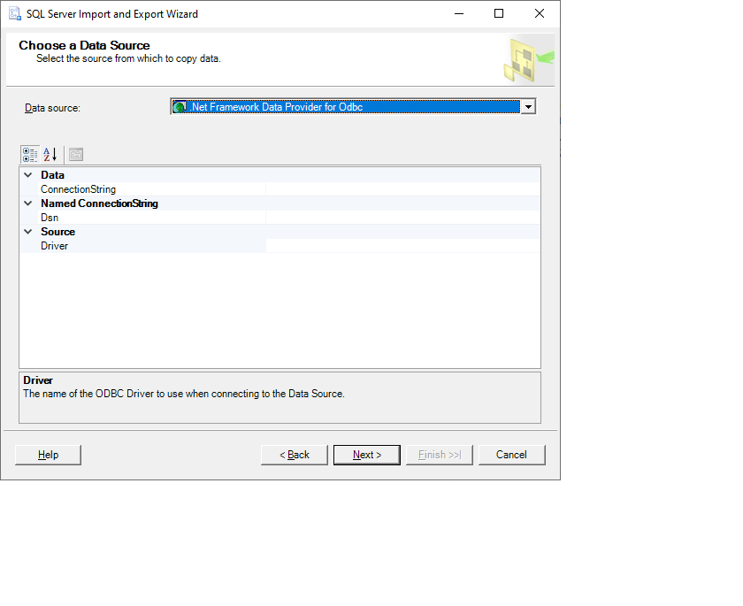


Change Data Source: click the drop-down arrow on the far right to view more data sources.
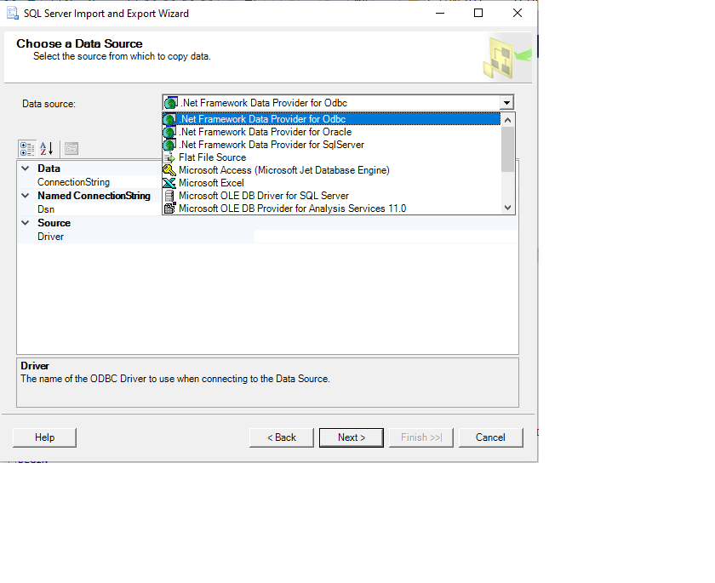

Select Flat File Source
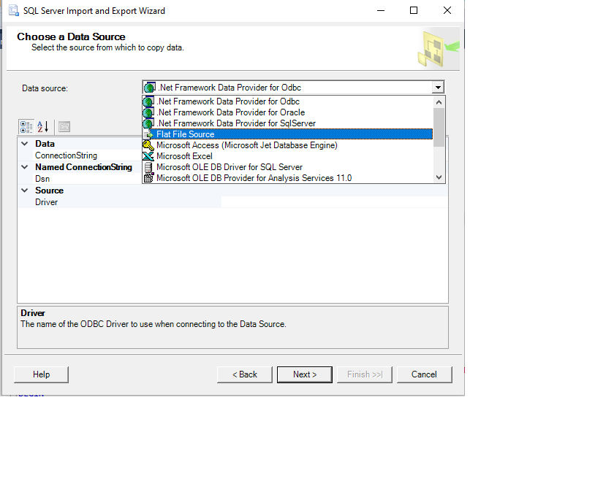
Flat File Source Options: click "Browse…" to find the file to import into SQL Server.

Note: several steps are performed here before moving onto the next screen:
Data source (provide the file location and name), "General", "Columns" and "Advanced" tabs
all require special edits.
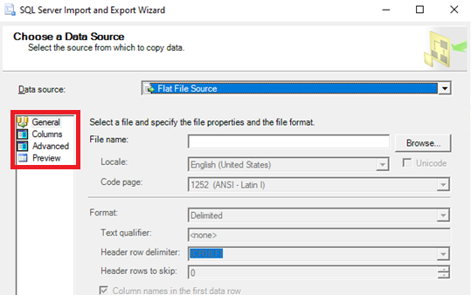
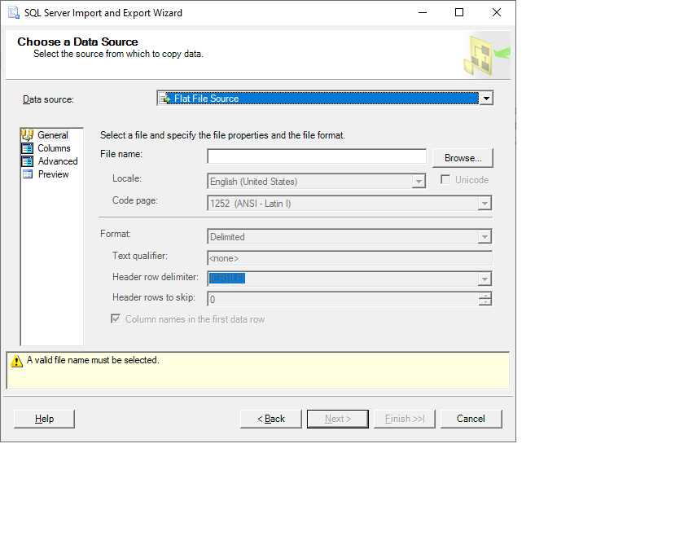

Flat File Source Options, "General":
This file isn't organized into columns, so the "Format" options don't make a lot of sense.
Be sure to uncheck "Column names in the first data row".
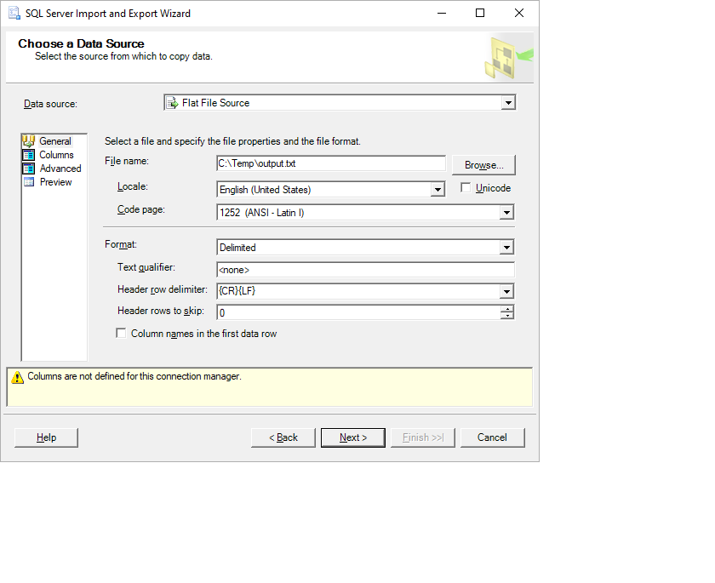

Flat File Source Column Options; click the "Columns" tab on the left
Technically, the whole file is a single column, with each line being a row or record imported into the database.
The delimiter for each row is a carriage return / line feed, or {CR}{LF}
The column delimiter doesn't make sense, since there is just a single, wide column in this scenario.
Make sure the column delimiter is blank or greyed out.
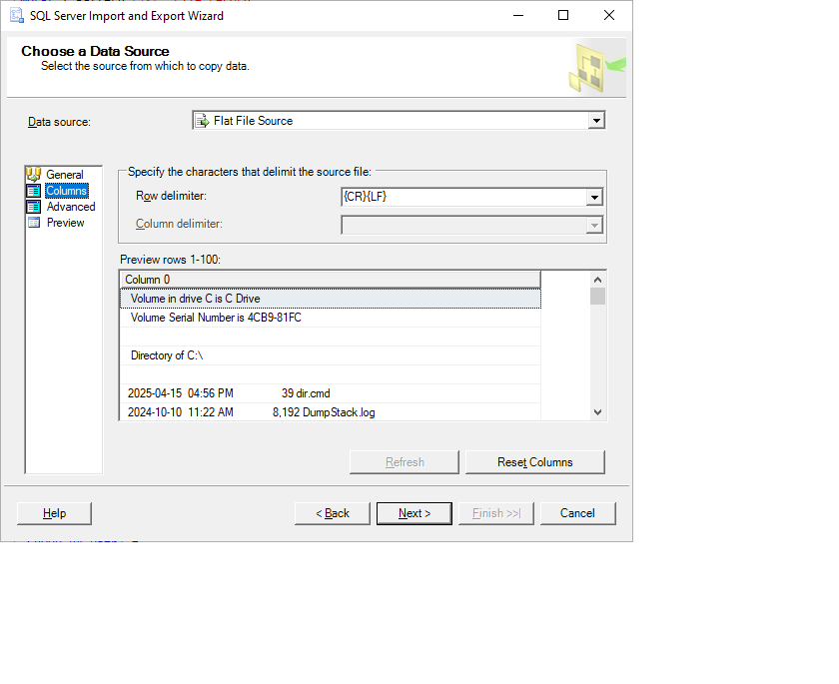
Flat File Source Advanced Options: click "Advanced" tab in the left.
Be sure to extend the OutputColumnWidth to at least 500 characters to avoid truncation errors on long lines.
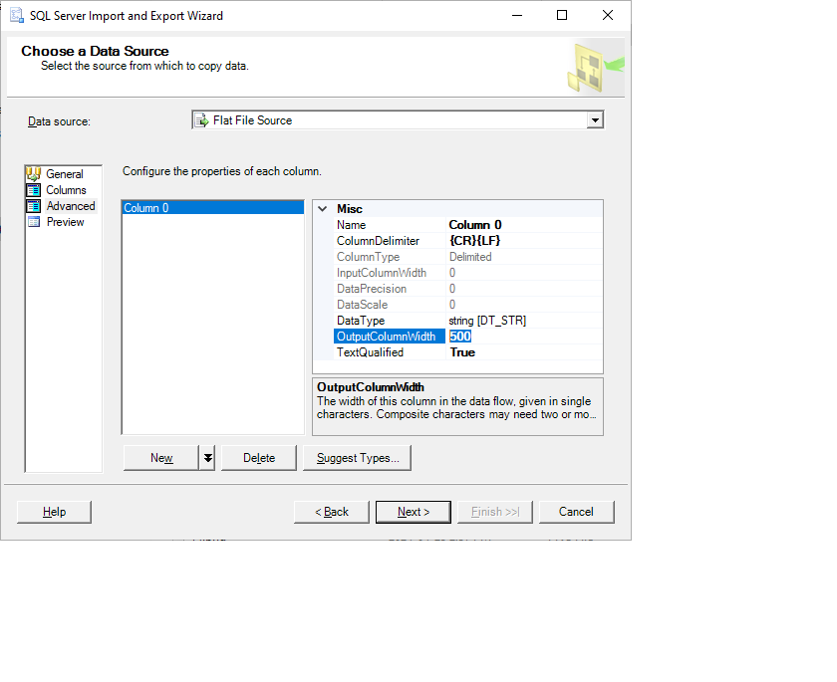

Choose a Destination
Choose "Microsoft OLE DB Driver for SQL Server".
".Net Framework Data Provider for SQL Server" also works but may take longer to import a large file.
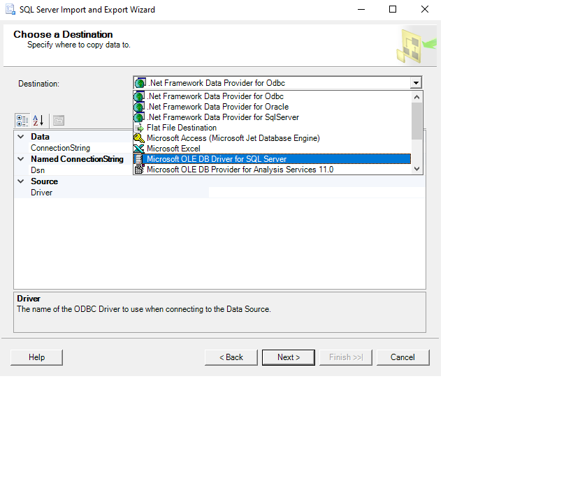

"Choose a Destination", Properties
Click "Properties…" to view database security options.
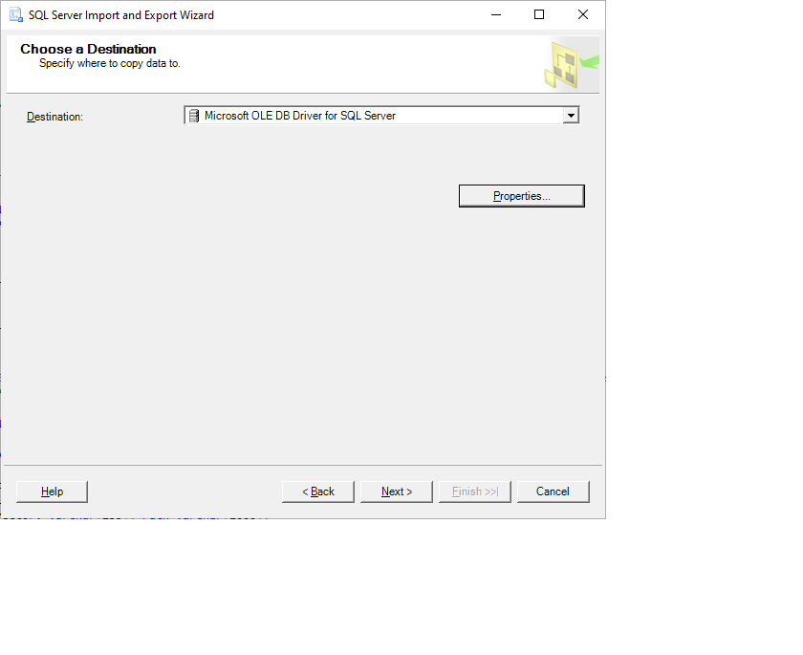

Data Link Properties: connect to a SQL Server, enter a user name and password, select a database.
Enter the server name if it doesn't automatically populate. It should be formatted like "Hostname\InstanceName".
"Enter information to log on to the server:" will accept a user name and password, or use Windows Authentication.
Select the database to import the file into. This example uses the tempdb database.
Finally, click "Test Connection" button in the lower right.
If successful, click "Next >"

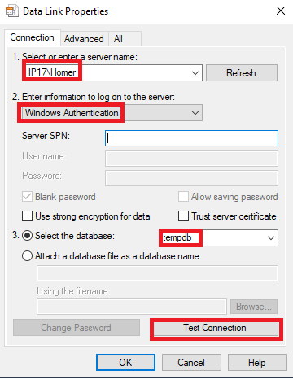

Test Connection Succeeded
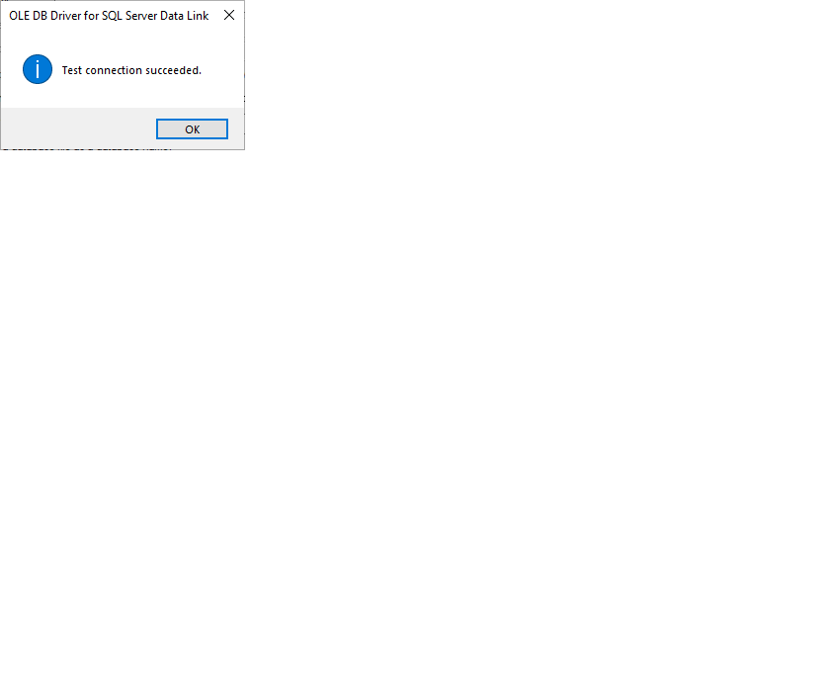

Select Source Tables and Views:
Click "Edit Mappings…" for an important edit.
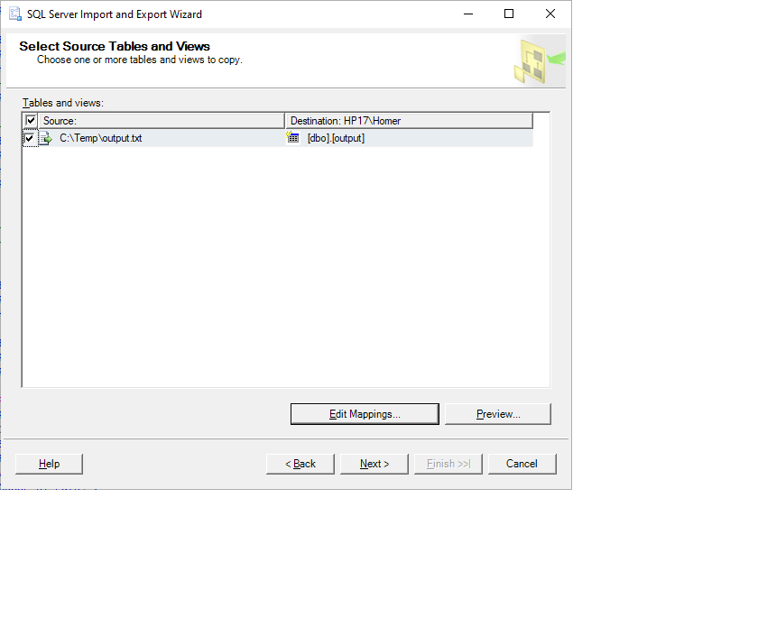

Column Mappings: text from the file is directed to specific columns in the database table.
In the next step, click "Edit SQL…" for an important change.
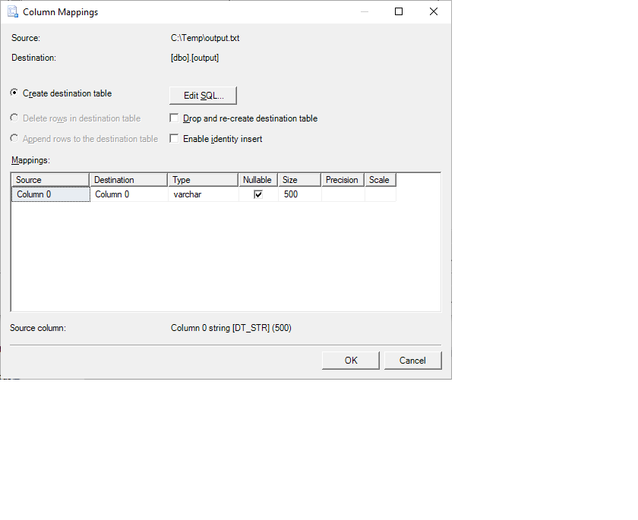

Edit SQL of Destination Table:
The table must contain an identifier to indicate the line number in the original file.
Otherwise, the lines of the file won't be inserted into the database table in order, and the directory name can't be matched to the file records that come after it. Edit the SQL text of the table definition to include
"ID int IDENTITY, " and include that before the column [Column 0] varchar(500)
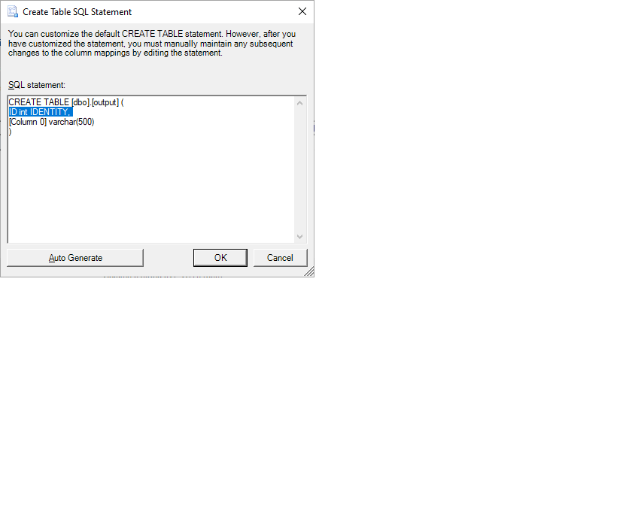

Select Source Tables and Views
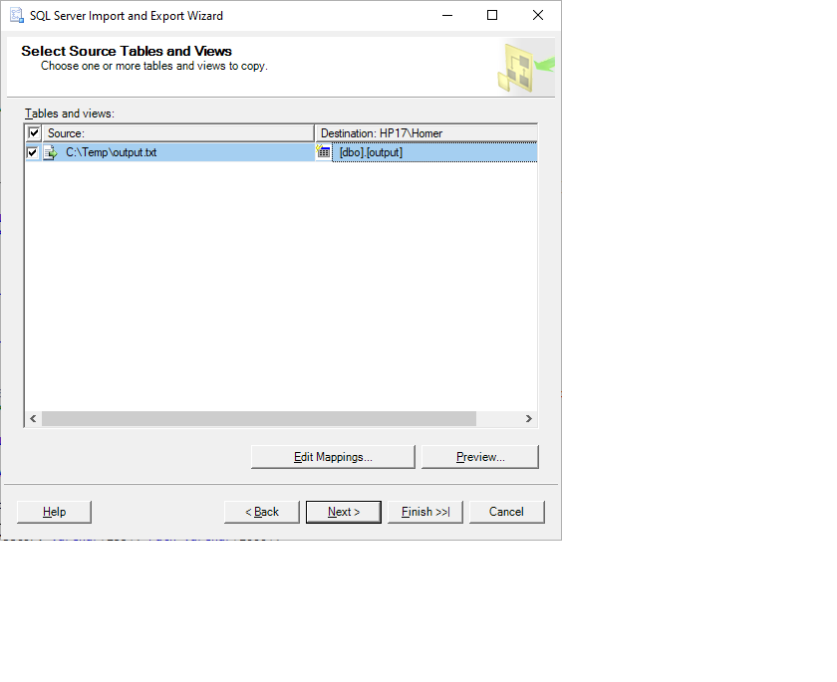

Data View: from " Select Source Tables and Views: Preview…"
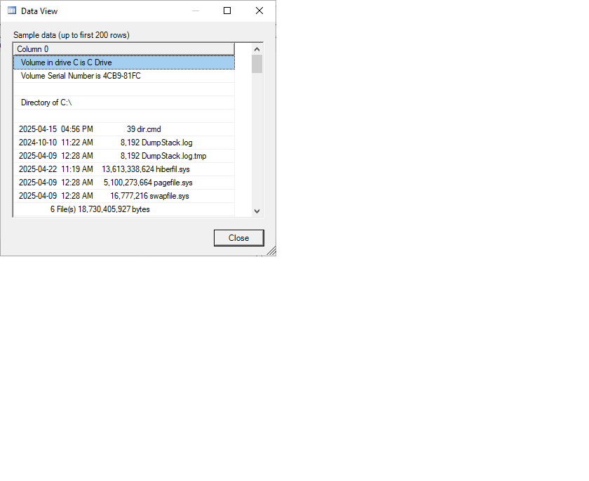
Save and Run Package
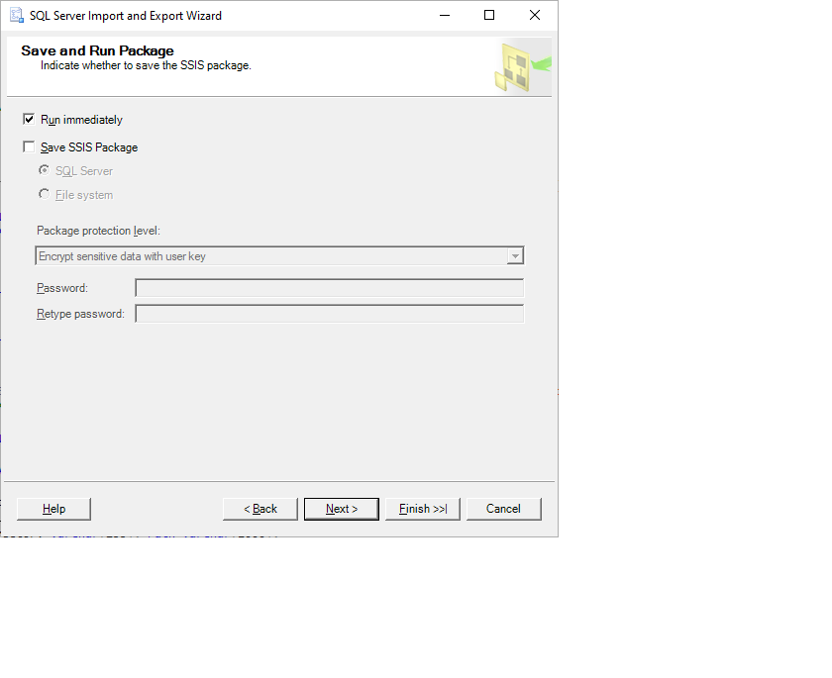

Click Finish to perform the following actions
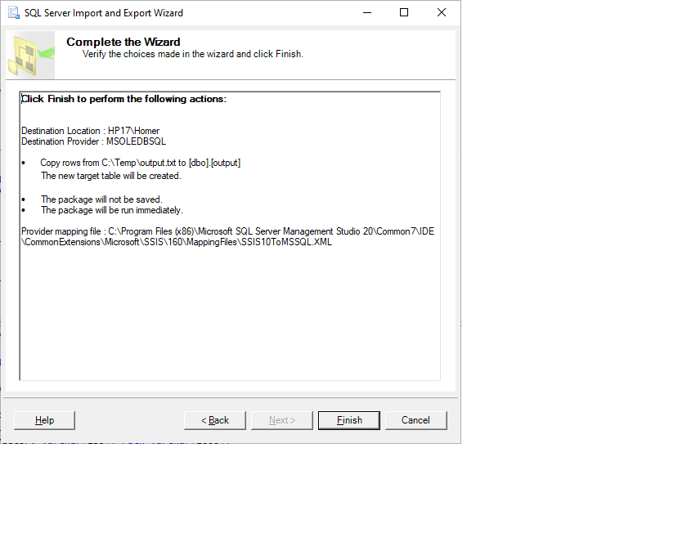

The execution was successful:
Note the rows transferred near the end of the output: compare this to the line numbers of output.txt
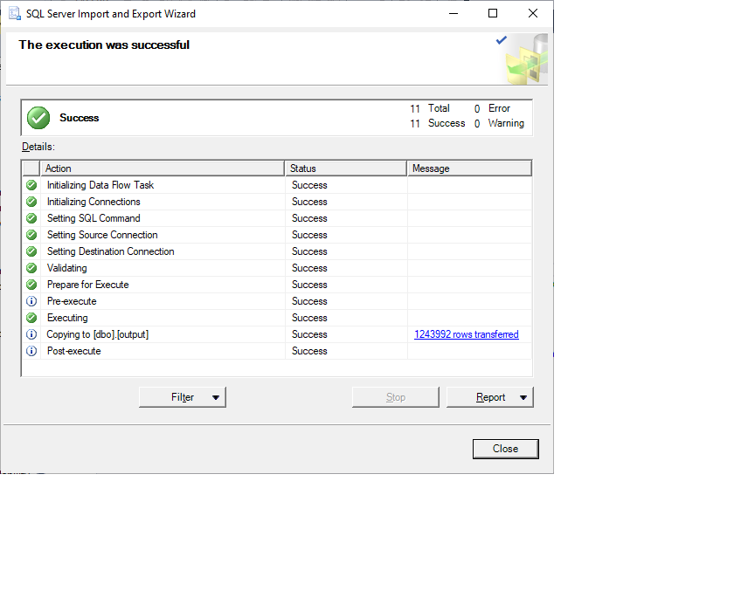

Database Queries
After the contents of the directory file have been imported into a database table, several steps using SQL (structured query language) are needed to change the file records into a relational format. The database is needed to connect, or "relate" directory names to the individual files they contain.
A series of directory names will be matched to a series of file names. The directory names are contained in a different table than the file names, but they will be connected, or "joined" in database terminology, to identify the directory name where each file is located. This will later assist the user to locate lost files.
Finally, the directory table can be queried to identify the largest folders, and likewise, the table of file records can be queried to identify the largest files, most recently created files, files with identical names but different folder locations and other criteria. This is the fun part: use queries to answer questions, like where is this file?!? Also, what is taking up so much space on this drive?
--DROP TABLE Tempdb.dbo.DirTextLines
CREATE TABLE Tempdb.dbo.DirTextLines
(ID int IDENTITY, Line varchar(2000),
DateChar varchar(20), Date smalldatetime,
Drive varchar(1), Pattern varchar(100),
Path varchar(1000), Filename varchar(500), PathAndFile varchar(2000),
SizeChar varchar(100), Size numeric(15,0), SizeMB numeric(15,3),
FileCountChar varchar(100), FileCount numeric(15,0))

--All columns in DirTextLines table
SELECT ID, Line, DateChar, Date, Pattern, Path, Filename, PathAndFile,
SizeChar, Size, SizeMB, FileCountChar, FileCount
FROM DirTextLines

--INSERT lines from output table into DirTextLines (table with more columns)
INSERT DirTextLines (Line)
SELECT [Column 0] FROM Output ORDER BY ID

--TRIM Line column before parsing into pattern
UPDATE Tempdb.dbo.DirTextLines SET Line = LTRIM(RTRIM(Line))
--No point in having rows with no information...
DELETE FROM Tempdb.dbo.DirTextLines WHERE Line IS NULL OR Line LIKE ''

--UPDATES to Tempdb.dbo.DirTextLines to parse lines of dir command output
--
--Get Date from strings that have this pattern
--First 20 characters like this:
--'[0-9][0-9][0-9][0-9]-[0-9][0-9]-[0-9][0-9] [0-9][0-9]:[0-9][0-9] [A|P]M'
UPDATE Tempdb.dbo.DirTextLines SET DateChar = SUBSTRING(Line, 1, 20)
WHERE SUBSTRING(Line, 1, 20)
LIKE '[0-9][0-9][0-9][0-9]-[0-9][0-9]-[0-9][0-9] [0-9][0-9]:[0-9][0-9] [A|P]M'
--Don't trust every pattern that looks like a date
UPDATE Tempdb.dbo.DirTextLines SET Date = CAST(DateChar AS smalldatetime)
WHERE ISDATE(DateChar) = 1

--Pattern is the most important column, because this value is used in WHERE clause of future UPDATES
--Re-set Pattern column
UPDATE Tempdb.dbo.DirTextLines SET Pattern = NULL

--Identify most patterns
--Seems to find a pattern for every line; no Unknown Pattern found yet.
UPDATE Tempdb.dbo.DirTextLines SET Pattern = CASE
WHEN SUBSTRING(Line, 1, 7) LIKE 'Volume ' THEN 'Volume record'
WHEN SUBSTRING(Line, 1, 13) LIKE 'Directory of ' THEN 'Directory of'
WHEN SUBSTRING(Line, 1, 20)
LIKE '[0-9][0-9][0-9][0-9]-[0-9][0-9]-[0-9][0-9] [0-9][0-9]:[0-9][0-9] [A|P]M'
THEN 'File record'
WHEN SUBSTRING(Line, 1, 45) LIKE '%[0-9] File(s)%[0-9] bytes' THEN 'Summary'
WHEN SUBSTRING(Line, 1, 19) LIKE 'Total Files Listed:'
OR Line LIKE '%[0-9] Dir(s)%[0-9] bytes free%'
THEN 'Final'
ELSE 'Unknown' END

SELECT COUNT(ID) AS Total, Pattern FROM DirTextLines GROUP BY Pattern ORDER BY Pattern

--BEGIN Updates to Path, Filename, PathAndFile, SizeChar, Size, SizeMB, FileCountChar, FileCount
--
--UPDATE Path
UPDATE Tempdb.dbo.DirTextLines SET Path = SUBSTRING(Line, 14, 2000)
WHERE Pattern LIKE 'Directory of'

--UPDATE Filename
UPDATE Tempdb.dbo.DirTextLines SET Filename = SUBSTRING(Line, 40, 2000)
WHERE Pattern LIKE 'File record'

--Path is used to group file records and calculate directory size
--Path column first needs an update from another table, Directories
--
--DROP TABLE Tempdb.dbo.Directories
CREATE TABLE Tempdb.dbo.Directories
(ID int IDENTITY, ThisID int, Path varchar(2000), NextID int,
Files int, Size numeric(15,0), SizeMB numeric(15,3))

INSERT Tempdb.dbo.Directories (ThisID, Path)
SELECT ID, Path FROM DirTextLines WHERE Pattern LIKE 'Directory of' ORDER BY ID

--Find NextID
UPDATE a SET a.NextID = b.ThisID
FROM Tempdb.dbo.Directories a JOIN Tempdb.dbo.Directories b ON a.ID + 1 = b.ID

--Should have a value in every Path
SELECT ID, ThisID, Path, NextID, Size, SizeMB
FROM Tempdb.dbo.Directories
WHERE Path IS NOT NULL

--UPDATE Path value in DirTextLines table, based on Path in 'Directory of' records in Directories table
--The 'File record' rows in DirTextLines table that immediately follow 'Directory of' records belong to that folder.
UPDATE f SET Path = d.Path
FROM Tempdb.dbo.DirTextLines f
JOIN Tempdb.dbo.Directories d
ON f.ID > d.ThisID AND f.ID < d.NextID
WHERE f.Pattern LIKE 'File record'

--With Path from 'Directory of' record before the 'File record' records, PathAndFile UPDATE will now work.
--PathAndFile
UPDATE Tempdb.dbo.DirTextLines SET PathAndFile = Path + '\' + Filename
WHERE Pattern LIKE 'File record'
--Occasionally an extra '\' in the PathAndFile
UPDATE Tempdb.dbo.DirTextLines SET PathAndFile = REPLACE(PathAndFile, 'C:\\', 'C:\')
WHERE Pattern LIKE 'File record' AND PathAndFile LIKE 'C:\\%'

--File size value found in the middle of 'File record' rows
UPDATE Tempdb.dbo.DirTextLines SET SizeChar = REPLACE(SUBSTRING(Line, 21, 18), ',', '')
WHERE Pattern LIKE 'File record'
UPDATE Tempdb.dbo.DirTextLines SET Size = SizeChar
WHERE Pattern LIKE 'File record'
AND ISNUMERIC(SizeChar) = 1

--Distinct pattern match WHERE Pattern IN ('Summary')
--This UPDATE gets the total number of files and the total byte count of all files in that folder
UPDATE Tempdb.dbo.DirTextLines SET
SizeChar = LTRIM(RTRIM(REPLACE(REPLACE(SUBSTRING(Line,
CHARINDEX('File(s)', Line) + 7, 1000), 'bytes', ''), ',', ''))),
FileCountChar = LTRIM(RTRIM(SUBSTRING(Line, 1, CHARINDEX(' File(s)', Line))))
FROM Tempdb.dbo.DirTextLines
WHERE Pattern IN ('Summary')

--SizeChar and FileCountChar columns
--Distinct pattern match WHERE Pattern IN ('Final')
UPDATE Tempdb.dbo.DirTextLines SET
SizeChar = CASE
WHEN Line LIKE '%[0-9] File(s)%'
THEN LTRIM(RTRIM(REPLACE(SUBSTRING(Line,
CHARINDEX('File(s)', Line) + 7, 1000), 'bytes', '')))
WHEN Line LIKE '%[0-9] Dir(s)%'
THEN LTRIM(RTRIM(REPLACE(SUBSTRING(Line,
CHARINDEX('Dir(s)', Line) + 6, 1000), 'bytes free', '')))
ELSE NULL END,
FileCountChar = CASE
WHEN Line LIKE '%[0-9] File(s)%'
THEN LTRIM(RTRIM(SUBSTRING(Line, 1, CHARINDEX(' File(s)', Line))))
WHEN Line LIKE '%[0-9] Dir(s)%'
THEN LTRIM(RTRIM(SUBSTRING(Line, 1, CHARINDEX(' Dir(s)', Line))))
ELSE NULL END
FROM Tempdb.dbo.DirTextLines
WHERE Pattern IN ('Final')

--Size from SizeChar
UPDATE Tempdb.dbo.DirTextLines SET Size =
CAST(REPLACE(SizeChar, ',', '') AS numeric)
WHERE Pattern IN ('Summary', 'Final')
AND ISNUMERIC(SizeChar) = 1

--Get a size in MB for Size
UPDATE Tempdb.dbo.DirTextLines SET SizeMB =
CAST(Size/(1024*1024 + 0.00001) AS numeric(15,3))

--FileCount (the column with numeric data)
UPDATE Tempdb.dbo.DirTextLines SET FileCount =
CAST(REPLACE(FileCountChar, ',', '') AS numeric)
WHERE Pattern IN ('Summary', 'Final')
AND ISNUMERIC(FileCountChar) = 1

--
--END Updates to Path, Filename, PathAndFile, SizeChar, Size, SizeMB, FileCountChar, FileCount
--UPDATE some 'Directory of' records
SELECT ID, Line, DateChar, Date, Pattern, Path, Filename, PathAndFile,
SizeChar, Size, SizeMB, FileCountChar, FileCount
FROM DirTextLines
WHERE Pattern LIKE 'Directory of'

--Get a summary value for 'Directory of', based on the 'File record' rows they contain
--Columns: Date (most recent date of files in this Directory), Size and SizeMB total size of files in the FileCount = total files
UPDATE d SET Size = f.TotalSize,
SizeMB = CAST(f.TotalSize/(1024*1024 + 0.00001) AS numeric(15,3)),
Date = f.MaxDate, FileCount = f.Total
FROM Tempdb.dbo.DirTextLines d
JOIN
(SELECT SUM(Size) AS TotalSize, MAX(Date) AS MaxDate, Path, COUNT(ID) AS Total
FROM Tempdb.dbo.DirTextLines
WHERE Pattern LIKE 'File record'
GROUP BY Path) f
ON d.Path = f.Path
WHERE d.Pattern LIKE 'Directory of'

--
--END of UPDATES to Tempdb.dbo.DirTextLines table
--

--The rest of this script queries the results to locate files, identify large files and folders, and search contents by dates.

--How much space is free?
SELECT CAST(Size/(1024*1024*1024 + 0.00001) AS numeric(15,2)) AS [SizeGB Free]
FROM DirTextLines
WHERE Pattern LIKE 'Final' AND Size IS NOT NULL

--How much space is currently used by folders?
SELECT CAST(SUM(Size)/(1024*1024*1024 + 0.00001) AS numeric(15,2)) AS [SizeGB Folders]
FROM DirTextLines
WHERE Pattern LIKE 'Directory of' AND Size IS NOT NULL

--How much space is currently used by files?
SELECT CAST(SUM(Size)/(1024*1024*1024 + 0.00001) AS numeric(15,2)) AS [SizeGB Files]
FROM DirTextLines
WHERE Pattern LIKE 'File record' AND Size IS NOT NULL

--Finding files and directories
--Here are some queries that can help locate files, directories and patterns in the directory output

--Find the largest Directories (based on the sum of file sizes at their root)
--If all subfolders are included, obviously the root of the drive (e.g., C:\) would be the largest folder.
SELECT ID, Date, Path, Size, SizeMB, FileCount
FROM DirTextLines
WHERE Pattern LIKE 'Directory of'
ORDER BY Size DESC

--Find the folder with the most files at the root (excludes subfolders)
SELECT ID, Date, Path, Size, SizeMB, FileCount
FROM DirTextLines
WHERE Pattern LIKE 'Directory of'
ORDER BY FileCount DESC

--Largest files
SELECT TOP 1000 ID, Pattern, Filename, Path, PathAndFile, Size, SizeMB
FROM DirTextLines
WHERE Pattern LIKE 'File record'
ORDER BY SizeMB DESC

--Looking for specific files:
--Photos, over one MB, within a specific time frame
SELECT ID, CONVERT(char(16), Date, 121) AS Date, Pattern, Filename, Path, SizeMB
FROM DirTextLines
WHERE Pattern LIKE 'File record' AND Filename LIKE '%.jpg'
--Exclude a lot of folders that probably don't have user files
AND ((Path NOT LIKE 'C:\Users%') AND (Path NOT LIKE 'C:\Recovery%')
AND (Path NOT LIKE 'C:\system%') AND (Path NOT LIKE 'C:\Program%')
AND (Path NOT LIKE 'C:\$%') AND (Path NOT LIKE 'C:\hp%') AND (Path NOT LIKE 'C:\Dell%')
AND (Path NOT LIKE 'C:\Windows%') AND (Path NOT LIKE 'C:\Python%'))
AND Date BETWEEN '2025-01-01' AND '2025-03-31'
AND SizeMB > 1
ORDER BY Date DESC

--Are there duplicate files?
SELECT f.ID, f.Date, f.Pattern, f.Path, f.Filename, f.Size, f.SizeMB,
d.Total AS [Duplicate files], d.TotalSizeMB
FROM Tempdb.dbo.DirTextLines f
JOIN
(SELECT FileName, COUNT(ID) AS Total, SUM(SizeMB) AS TotalSizeMB
FROM Tempdb.dbo.DirTextLines
WHERE Pattern LIKE 'File record' GROUP BY Filename HAVING COUNT(*) > 1) d
ON f.Filename = d.Filename
--Exclude a lot of folders that probably don't have user files
WHERE ((f.Path NOT LIKE 'C:\Users%') AND (f.Path NOT LIKE 'C:\Recovery%')
AND (f.Path NOT LIKE 'C:\system%') AND (f.Path NOT LIKE 'C:\Program%')
AND (f.Path NOT LIKE 'C:\$%') AND (f.Path NOT LIKE 'C:\hp%') AND (f.Path NOT LIKE 'C:\Dell%')
AND (f.Path NOT LIKE 'C:\Windows%') AND (f.Path NOT LIKE 'C:\Python%'))
--Next ORDER BY: find records with identical filenames
--ORDER BY f.Filename, f.Date DESC
--Next ORDER BY: find duplicate filenames,
-- but find larger files to delete duplicates, and free up space
ORDER BY d.TotalSizeMB DESC, f.Filename, f.Date DESC

************************************************************************************************
The dir command

The dir command is a very old but still used operating system command to list all the files in a file system folder.
This document begins with the dir command, directing the output to a file that is later processed with database queries.
The database transforms the dir command output from a non-relational to a relational format,
so that files and folders can be identified with SQL queries instead of searching through text files with limited editing commands.

This is a great reference site for more information:
https://www.computerhope.com/
https://www.computerhope.com/dirhlp.htm

dir is the simple operating system command.
/s and /A are "switches" or options to change the contents or format of the output.
The symbol ">" directs the command to write the output to a file.

This example shows the directory scan of the entire C:\ drive, with output directed to a file in another folder, "C:\Temp\output.txt"
It may be necessary to direct the output to a different folder,
if the user doesn't have permissions to write to the root of the C:\ drive.
This command can be customized to return a very specific set of files.
Try these two versions of the command and compare their very different output files.

All details of file records, including subfolders, with output directed to a file in another folder.
dir *.* /s /A-D >"C:\Temp\output.txt"

Just the path and file of every file directed to output.txt in the same folder:
dir *.* /s /A /B >output.txt
************************************************************************************************

************************************************************************************************
Essentials of the Database Environment

Client and server terminology
A database server is needed to import data from other sources, like flat files or spreadsheets.
A "server" is required to receive database commands from a client.
A "client" is required to send database commands like "SELECT" queries to a database server.

Downloading and installing a database client will enable connecting to a database server:
SQL Server Management Studio
https://learn.microsoft.com/en-us/ssms/download-sql-server-management-studio-ssms

Downloading and installing a database server:
Microsoft SQL Server is available as a free download (certain editions):
https://www.microsoft.com/en-us/sql-server/sql-server-downloads

Download a free specialized edition:
Developer
SQL Server 2022 Developer is a full-featured free edition,
licensed for use as a development and test database in a non-production environment.
Express
SQL Server 2022 Express is a free edition of SQL Server,
ideal for development and production for desktop, web, and small server applications.

Microsoft SQL Server is also available for download from third parties, which might offer earlier versions with fewer installation requirements. Using Microsoft SQL Server in a production setting for commercial purposes
requires purchase and is subject to licensing terms.

Using the import file feature of Microsoft SQL Server:
https://learn.microsoft.com/en-us/sql/relational-databases/import-export/import-flat-file-wizard?view=sql-server-ver16
What is the most recent version of Microsoft SQL Server?
https://sqlserverbuilds.blogspot.com/
SQL Server 2025 (SQL Server version 17) was announced on November 18, 2025.
SQL Server 2022 (SQL Server version 16) was released to manufacturing (RTM)
on November 16, 2022.
Its version number is: 17.0.1000.7 (RTM), with most recent CU5 (17.0.4045.5, May 2026)
************************************************************************************************

